STALL BOOKING FORM & EXHIBITION CATALOGUE FORM

PLEASE FILL THE FORM IN ENGLISH (CAPITAL LETTERS) ONLY.

* Required Field
Company Name: *
Address & Postal Code: *
State:
Country:
Tel:
Mobile: *
E-mail 1:*
E-mail 2:
Website:
Managing Director / CEO:
Marketing Manager:
Contact Person: *
Company Description:
(up to 30 words)

NOTE: Company Profile received after deadline date will not entered in the Exhibitor Catalogue.

Date & Venue: _______________________________________________________________________

Hall No: -____________ Stall No: -___________ Size of your Stall (in Sq. mtr):-___________________

* Name of the Company / Organization, for Name Fascia Board: - (English Alphabet Only).

*Your Company Logo (to link in Exhibition website)
Please Attach Your Company Logo here or Attach in Email with this filled form.

* Memento Name: -

* Exhibitor Badges
• Please Email a separate sheet if space given is insufficient.

Sr. No. | Company Name | Exhibitor’s Name | Designation | CELL NO | EMAIL ADDRESS

Note: Exhibitors badges names not received by the deadline date may cause delay on site in receiving the badges.

PARTICIPATION CHARGES
Standard Stand Construction | Raw Space
INDIA: Rs. Per Sq. Mtr  FOREIGN: $ Per Sq. Mtr | INDIA: Rs. Per Sq. Mtr  FOREIGN: $ Per Sq. Mtr
Total: | Total:

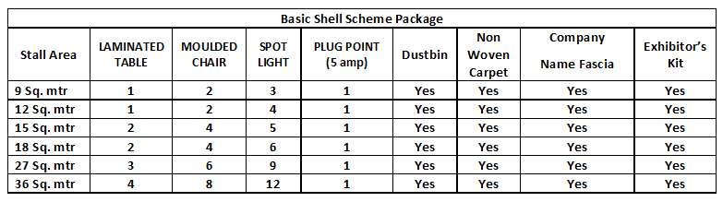
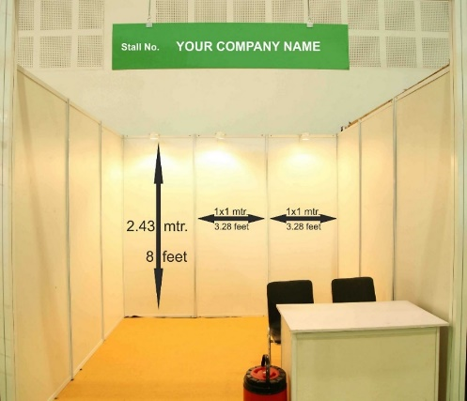

The Octanorm System will be used, which consists of 4mm hardboard panels (wood with white coating) positioned in white aluminium frames. Please note that these are not load bearing walls and it is forbidden to affix anything to the panels using nails, screws or glue. Any damage caused to the panels will be charged directly back to the exhibitor.

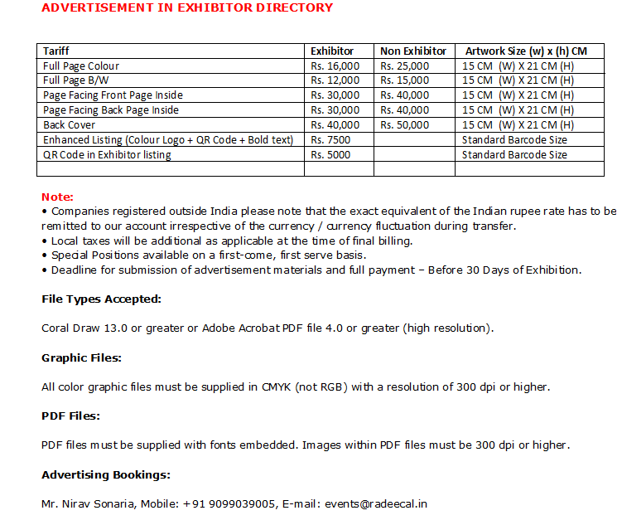

BANKING DETAILS:-

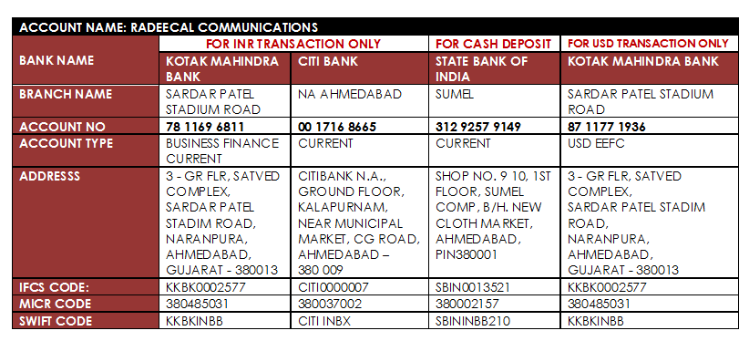
Note:
- Kindly use following priority
1) Kotak bank account
2) Citi bank
3) State bank of India

- For International transaction use Kotak bank USD EEFC account only

PAYMENT SHOULD BE MADE IN FAVOR OF “RADEECAL COMMUNICATIONS”
We have read the terms & conditions mentioned overleaf and agree by the same In the case of counter sale.
The payment of sale tax as applicable to the concerned Authorities will be the direct responsibility of the exhibitors. Service Tax will be charged extra as per existing norms.

